NBF AI Script Anomaly Detection
Hostdaemon Analysis and Correlation

Juan Luna-Camposano
Engineering Spec Aide

Table of Contents
1. Purpose 1
2. Common Terms and Definitions 1
3. Proposition 2
3.1 Background 2
3.2 Execution 2
3.3 Applications 3
4. Conclusion 3

Figure 1-Overview of a DART Report for t_VMFF_Existing_CAS_OSR_Mod.py 2
Figure 2-Excerpt of hostdaemon file for Batch 73955 2
Figure 3-Concept of Correlation Information Display 3

Table 1-Common Terms and Definitions 1

Purpose
The purpose of this document is to convey the proposition for establishing a correlation between the hostdaemon files (log files) to the DART Report.

Common Terms and Definitions
The common terms and definitions used in this document are listed below.
Term | Definition
DART Report | Report that provides a concise view of executed batches.
Hostdaemon file | A log file that records every action within the simulation environment.
Batch ID | A serialized number assigned to each automated script test execution.
Table 1-Common Terms and Definitions

Proposition
The tool designated by the NBF AI Script Anomaly Detection team should be able to read hostdaemon files associated with a script execution and decide on the cause of recorded failures on the DART Report.

3.1 Background
The DART Report provides a concise summary of an executed set of automated scripts including the results and the simulation host that executed the script. Detailed information about the results is not presented in the DART Report and requires a manual review of the hostdaemon file (log file) of the associated batch.
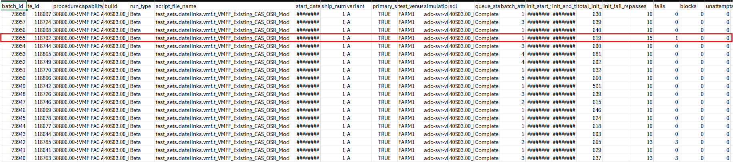
Figure 1-Overview of a DART Report for t_VMFF_Existing_CAS_OSR_Mod.py
The hostdaemon file records every action leading to the test execution, the test execution itself, and the conclusion of the test. The test environment is documented detailing what components of the test environment failed and the occurrence of the script failure.
When a failure is recorded in the DART Report, the tool should be able to read the associated hostdaemon file and provide exact details on the recorded failure.
In Figure 1, the highlighted batch is Batch ID 73955. A review of the associated hostdaemon file details the test step where the failure occurred and an explanation of the recorded failure.
Figure 2-Excerpt of hostdaemon file for Batch 73955

3.2 Execution
The correlation yields opportunities to better improve the tool’s decision machine as to the cause of recorded script failures beyond what the DART Report provides.
The execution of this proposition is the tool establishes a correlation between the DART Report and the associated hostdaemon files using Batch IDs. The tool then draws from the expanded information provided by the hostdaemon to elaborate the cause of the observed failures for each Batch ID. The tool would decide if any environmental factors led to the recorded script failure and/or code errors within the script itself and whether the same failure was observed in previous batches.
This information could be displayed on a table that filters down to the test point and presents that information alongside the test point as well.
Batch ID | Test Point | Description | Cause
73995 | [-4] | The Datalink Notification Text Window did NOT flash for 5 seconds and/or did NOT remained solid. | Environment – Node MPA3A0 Dead; Node MPA3A1 Dead
Figure 3-Concept of Correlation Information Display

3.3 Applications
The correlation between the DART Report and the associated hostdaemon files yields potential features that can be included in the tool.
Simulation Host Health can be expanded down to the granular environment components and provide better diagnoses for abnormal performance.
Another application is simulation execution forecasts where the expected simulation behavior can be forecasted prior to full automated testing, simulation health data is drawn and analyzed from the executed run, future forecasts are made based on the conclusion. This application is akin to weather forecasting where weather predictions are made, analyses are conducted after the event, and future forecasts are improved from the conclusions of prior forecasts.

Conclusion
The correlation between the DART Report and the associated hostdaemon files expands the NBF AI Script Anomaly Detection tool to factor environmental issues that yield a failure during script execution. The conclusions made by the tool will be more accurate beyond using patterns to determine script failures.

